|  |  |  |
| --- | --- | --- |
| **COLEGIO INSTITUTO TECNICO INTERNACIONAL IED.**  **P.E.I. EDUCACIÓN EN TECNOLOGÍA Y SU INFLUENCIA EN LA CALIDAD DE VIDA** | | |
| **DOCENTE: CONSUELO MARTINEZ** | **ASIGNATURA: INGLÉS** | **GRADO: 901, 902, 903** |
| **CÓDIGO: II-02-19-07-2021** | **TEMA: Superlatives** | |
| **GRADE:NINTH** | **NAME:** | |

**El taller debe ser resuelto y enviado en la fecha establecida al correo consuelo.martinez@iedtecnicointernacional para las personas que no tienen internet. La fecha establecida es viernes 23 de julio de 2021**

DESEMPEÑOS

Identifica la estructura de los superlativos en inglés.

Produce ejemplos en inglés, utilizando los superlativos.

RULES FOR USING SUPERLATIVES

|  |  |  |  |
| --- | --- | --- | --- |
| **RULES** | **ADJECTIVES** | **SUPERLATIVE** | **EXAMPLES** |
| **1 o 2 syllables add -est** | tall  short | the tallest  the shortest | He is the shortest student in the classroom. |
| **3 o + syllables add -the most- at the beginning** | intelligent  ambitious  sophisticated | the most intelligent  the most ambitious  the most sophisticated | The most creative project will win the contest. |
| **-y add -iest** | happy  funny | the happiest  the funniest | We are the happiest children in the world. |
| **-e add -st** | large  brave | the largest  the bravest | They are the bravest soldiers in the army. |
| **C+V+C= Double last consonant** | big  fat | the biggest  the fattest | China is the biggest country I have visited. |
| **Irregular forms** | Good  Bad  Far | the best  the worst  the farthest | Alaska is the farthest place I have been to. |

1. Write the superlative forms.
   1. New _____________________
   2. Near ________________________
   3. Noisy _______________________
   4. Thin ______________________
   5. Cheap ______________________
   6. Clean ______________________
   7. Cold ______________________
   8. Dark ______________________
   9. Light ______________________
   10. Safe ______________________
   11. Sweet ______________________
   12. Warm ______________________
2. Complete with the adjective in superlative form.
   1. The church is (old) ______________ building in our town.
   2. John is (careful) _______________ driver I know.
   3. This chair is (comfortable) ______________ in the house.
   4. Today was (tiring) ________________ day of my life.
   5. Einstein was (clever) ________________ man of the twentieth century.
   6. Annie is (young) ______________ person in my family.
   7. It was (tasty) ________________ soup I’ve ever eaten.
   8. Bob is (bad) ________________ player in our team.
   9. Snails and turtles are ________________ animals of all.
   10. Bill Gates has been (rich) ________________ person in the world for many years.
3. Choose the adjective from the box that best fits the sentence below and write the adjective in its correct superlative form.

|  |
| --- |
| * bad * comfortable * difficult * easy * enjoyable * exciting * expensive * funny * good * high * hot * important * large * sad * useful * young |

1. 2+2 = 4 This is the _________________ mathematics problem you will ever have.
2. John did well in the test, Sally did better, but Miho got the ___________ grade.
3. Everest is the world’s _______________ mountain.
4. Lucas is the ______________ student in the class. This means that he was born later than everyone else.
5. The ________________ thing that you can do as an ESL is learn words.
6. She is the __________________ singer I have ever heard. Her voice is like a cat wailing in the night.
7. What’s the _______________ joke you’ve ever heard?
8. Yesterday it was 45ºC, the ______________ day of the year so far.
9. For some students maths is the ________________ subject they take.
10. The _______________ planet in the solar system is Jupyter.
11. Narnia was the _______________ film I have ever seen.
12. We had a great holiday. In fact, I think it was the _____________ I have ever had.
13. The mobile phone must be one of the ___________________ inventions of all time.
14. A lamborghini is one of the __________________ cars you can buy.
15. It was one of the _________________ days of my life when our old dog died.
16. This is the ___________________ chair I have sat in for a long time.

4. Read the text. Later, Read the following statements and say if they are True or False.

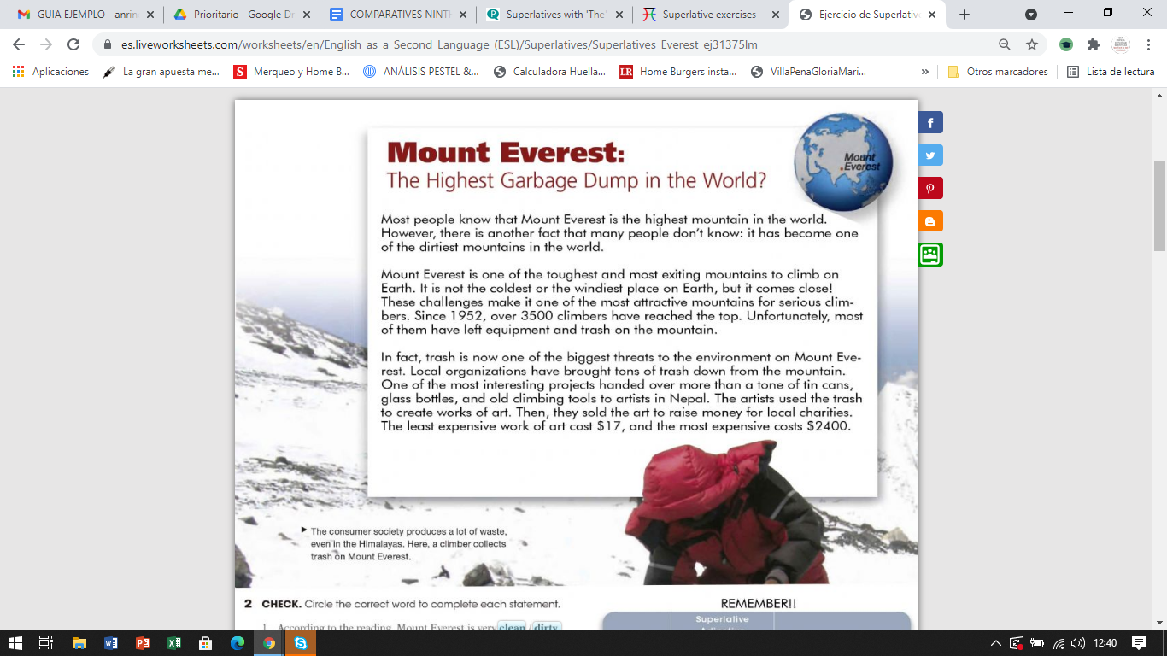

1. The Mount Everest is the coldest place in the earth. _____________________.
2. One of the most interesting projects have brought tons of trash down from the mountain. __________________.
3. The least expensive work of art costs $2400. ____________________.

5. Based on the previous text. Write three examples in each column of the chart.

|  |  |
| --- | --- |
| **Adjectives with -est** | **Adjectives with most** |
|  |  |

6. Based on the previous text. Circle the correct word to complete each statement.

1. According to the reading, Mount Everest is very **clean/dirty .**
2. Climbing Mount Everest is very **difficult/easy .**
3. Mount Everest is **an unusual/a popular** mountain for serious climbers.
4. Climbers **rarely/often** leave trash on Mount Everest.
5. People create **art/charities** from the trash on Mount Everest.