1. **INTRODUCCIÓN:**

El taller debe ser resuelto y enviado en la fecha establecida al correo [consuelo.martinez@iedtecnicointernacional](mailto:consuelo.martinez@iedtecnicointernacional) para las personas que no tienen internet.

Los demás estudiantes deben subir el taller a classroom:

901: 7izrbqu 902: 2snt2ln 903: ccs2qzm

1. **CONCEPTUALIZACIÓN:**

**DESEMPEÑO**: Lee y comprende textos en presente continuous

1. **DESARROLLO DEL TEMA:**

GRAMMAR FOCUS

El presente continuo o progresivo me indica que la acción se está realizando en el momento, el auxiliar es el verbo to Be, a los verbos se les debe agregar el ing(ando, endo)

Yo estoy leyendo un libro

I am reading a book

The carpenter is making a table

|  |  |
| --- | --- |
| AFFIRMATIVE | SHE IS EATING AN APPLE |
| NEGATIVE | SHE IS NOT EATING AN APPLE |
| INTERROGATIVE | IS SHE EATING AN APPLE? |

**A. Look at the image. Describe what are people doing? (Mire la imagen y describa que estàn haciendo los personajes usando el presente continuous**

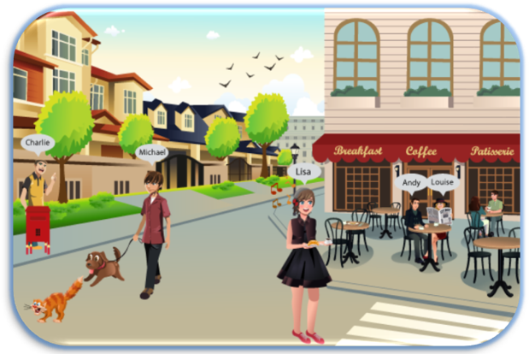

1.

**Charlie…………………………………………………….**

**Michael……………………………………………………..**

**Lisa………………………………………………………….**

**Andy………………………………………………………..**

**Louise………………………………………………………**

**B. WRITE SENTENCES  WITH THE WORDS IN PARENTHESES AND THE PRESENT CONTINUOUS OR PROGRESSIVE**

**0. (**He/ paint/ his house).He is painting his house……………………………... .............

**(** I/ wash/ my hair) ………………………………………………………………………….

(It/ snow)...................................................................................................................

(I/ sit/ on a chair).......................................................................................................

( He/ eat/ a piece of bread)........................................................................................

(they/sing/ in a concert)..............................................................................................

(She/ listen/ a song)...................................................................................................

(The sun/shine)..........................................................................................................

(I/ wear/ shoes)..........................................................................................................

( I/ read/ a newspaper)..............................................................................................

We/ watch/ TV)........................................................................................................

C**. WRITE THE FOLLOWING SENTENCES IN INTERROGATIVE ( ESCRIBA LAS SIGUIENTES ORACIONES EN INTERROGATIVA)**

**Example 1.** The waiter is serving in a restaurant

**Is the waiter serving in a restaurant?**

**Example** 2.Students are paying attention to the teacher

**Are students paying attention to the teacher?**

He is fishing in the river

………………………………………………………………………………….

 Students are doing the homework

           …………………………………………………………………………………..

My father is reading the newspaper

……………………………………………………………………………………

My mother is preparing an apple cake

…………………………………………………………………………………...

My brother is playing cards with his friends

…………………………………………………………………………………...

They are sleeping in your bed

…………………………………………………………………………………..

She is combing her hair

…………………………………………………………………………………..

The girl is dancing ballet

           …………………………………………………………………………………...

The mechanic is fixing the red car

…………………………………………………………………………………..

He is brushing his teeth

**D.ACCORDING TO THE TEXT, ANSWER THESE QUESTIONS**

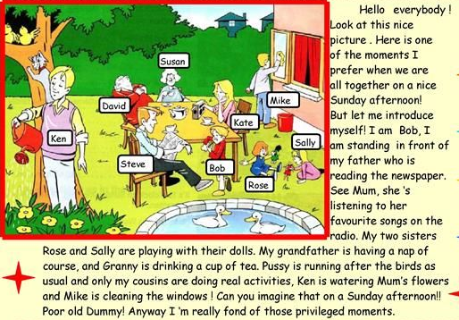

1. Where does the scene take place?

………………………………………………………………………………..

1. Who is speaking?

………………………………………………………………………………...

1. Who is drinking a cup of tea?

…………………………………………………………………………………

1. What are the little girls doing?

…………………………………………………………………………………

1. What's the cat's name? What is doing?

………………………………………………………………………………...

1. Where is Ken standing?

………………………………………………………………………………...

1. What is ken doing?

………………………………………………………………………………...

1. Who is reading the newspaper?

………………………………………………………………………………...

1. Who is sleeping?

………………………………………………………………………………...

1. What is Mike doing?

……………………………