Asignatura | Inglés. |  | Docente | Sandra J. González M. | Jornada |  | Mañana.
Correo Docente |  | sandra.gonzalez@iedtecnicointernacional.edu.co |  |  | Curso | 1001/2/3/4
Topic: Simple Present Tense / Vocabulary (sports, hobbies), verbs(enjoy, want, like, hate). 1
Objective: Listen and understand essential vocabulary and information from a text about hobbies, leisure activities and entertainment giving the general idea and some specific ideas about it.
ACTIVITIES
A. Match the pictures to the sports and hobbies.
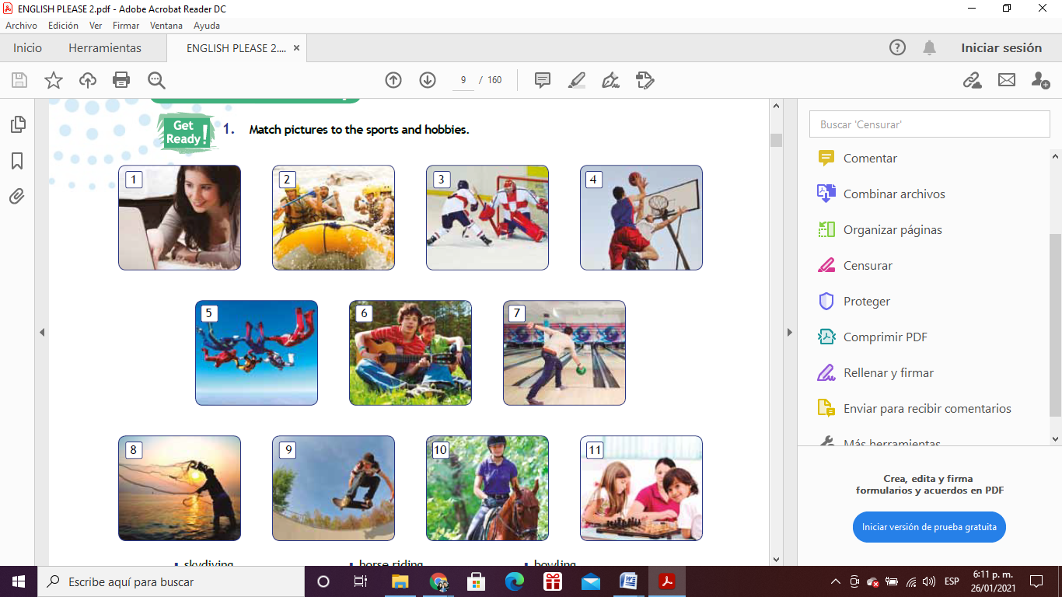
5 | Skydiving |  | Playing ice hockey
 | Chatting online |  | Playing board games
 | Bowling |  | White water rafting
 | Skateboarding |  | Horse riding
 | Fishing |  | Playing basketball
 | Playing music

B. Find the sports and hobbies in the activity A into the following word search.
w | h | i | t | e | w | a | t | e | r | f | a | f | t | i | n | g | i | c | e
o | p | p | e | n | d | e | a | r | s | t | u | i | d | y | i | n | g | h | s
k | e | l | p | l | a | i | c | o | u | r | s | s | y | l | d | i | g | a | p
a | o | a | r | t | i | l | y | w | o | r | k | h | p | a | i | d | m | t | o
e | p | y | c | r | o | t | c | q | w | e | r | i | t | y | u | i | I | t | o
p | l | i | a | g | s | h | l | g | f | g | d | n | s | a | p | r | o | i | n
s | e | n | r | n | j | k | i | l | ñ | n | z | g | x | c | v | e | B | n | i
c | t | g | r | i | z | x | n | c | v | i | b | g | n | m | m | s | n | g | g
i | e | i | u | l | a | s | g | d | f | v | n | f | g | h | j | r | K | o | n
s | e | c | l | w | w | e | r | t | y | i | u | i | o | p | ñ | o | l | n | i
u | n | e | e | o | q | a | z | x | d | d | s | w | e | d | c | h | v | l | p
m | a | h | r | b | j | u | y | r | h | y | n | b | g | t | r | e | f | i | m
g | g | o | b | u | k | i | a | l | o | k | ñ | p | ñ | o | l | h | o | n | u
n | e | c | o | m | o | o | c | s | o | s | d | r | o | t | a | a | l | e | j
i | r | k | o | o | b | e | s | t | b | a | s | k | e | t | b | a | l | l | e
y | h | e | m | e | a | n | e | q | o | s | r | p | e | c | u | e | m | y | e
a | u | y | t | I | e | n | v | n | b | e | i | b | n | e | c | i | b | u | g
l | n | a | s | d | o | a | s | l | e | i | e | n | b | c | l | o | e | m | n
p | k | l | e | d | i | s | n | e | y | s | q | d | d | o | e | n | s | u | u
s | p | l | a | y | i | n | g | b | o | a | r | d | g | a | m | e | s | u | b

C. Classify the sports or hobbies words found in the word search in the chart below.

SPORTS | HOBBIES
Bungee jumping

VERBS : HATE, LOVE, LIKE, ENJOY
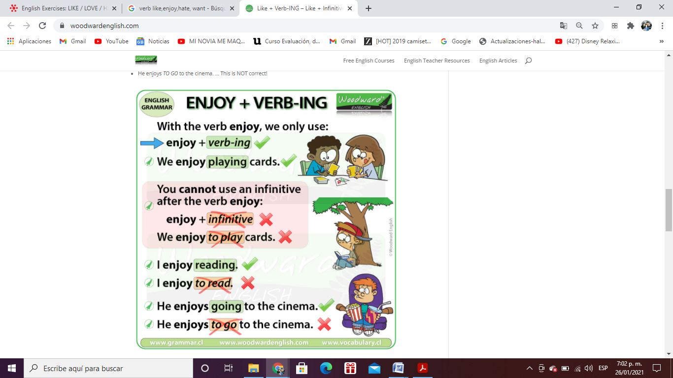

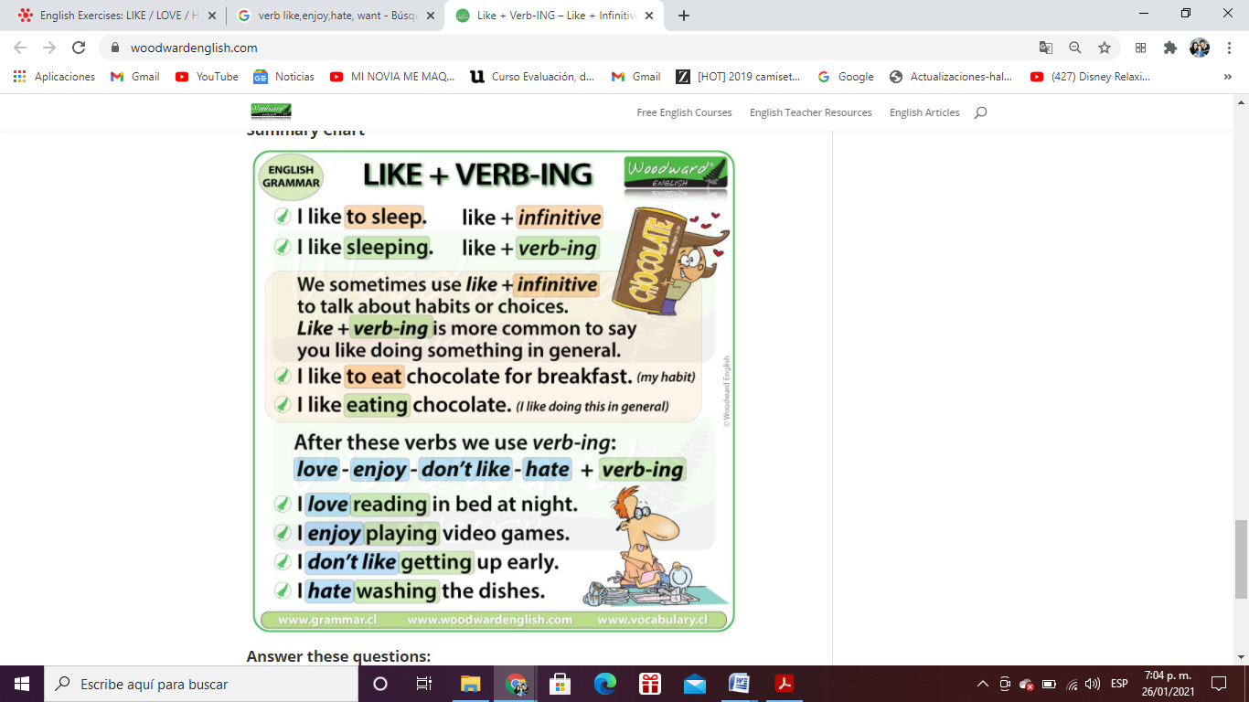

D. Write 5 sentences using vocabulary about sports and hobbies and the verbs: like, enjoy, hate and want.

1.________________________________________________________________________________
2. ________________________________________________________________________________
3. ________________________________________________________________________________
4. ________________________________________________________________________________
5. ________________________________________________________________________________

E. Look at the pictures and discuss with a partner.

1. Do you think Parkour is a sport or a hobby? ______________________________________________
2. Do you think that it is a team or individual sport/hobby?_____________________________________
3. What do you need if you want to do Parkour? ____________________________________________

F. Read the article and check your predictions.

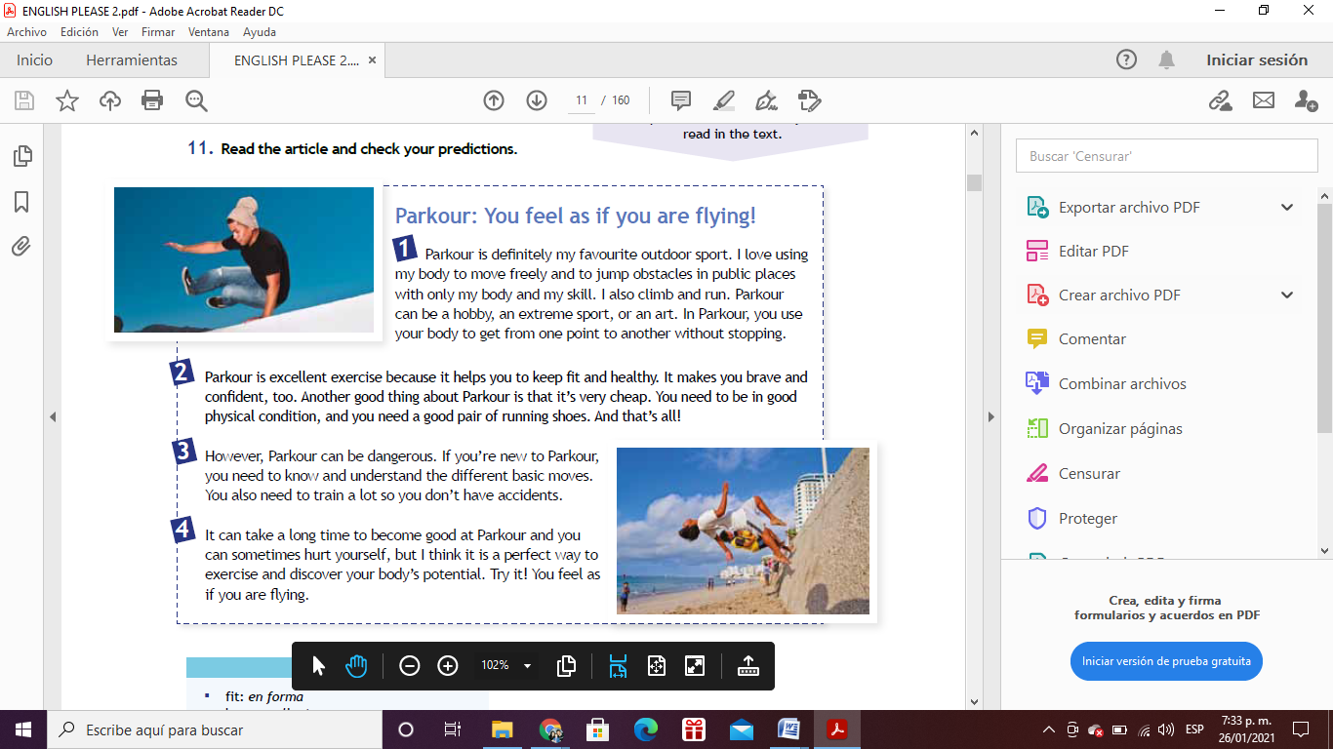

G. Read the sentences and write true (T) or false (F).

1. Parkour is only a sport. ( )
2. It´s expensive to do Parkour. ( )
3. Parkour isn´t always safe. ( )
4. You can become good at Parkour very quickly. ( )

