1. **INTRODUCCIÓN.**

El taller debe ser resuelto y enviado en la fecha establecida al correo [consuelo.martinez@iedtecnicointernacional](mailto:consuelo.martinez@iedtecnicointernacional) para las personas que no tienen internet.

Los demás estudiantes deben subir el taller a classroom:

901: 7izrbqu 902: 2snt2ln 903: ccs2qzm

1. **CONCEPTUALIZACIÓN**

DESEMPEÑO: Lee y comprende textos en presente simple.

**III. DESARROLLO:**

*1.ANSWER ABOUT YOURSELF*

What is your full name?

**-------------------------------------------**

What is your occupation?

**-------------------------------------------**

How many brothers or sisters do you have?

**--------------------------------------------**

What is your favorite TV program?

**---------------------------------------------**

How old are you?

**2. CHOOSE THE CORRECT FORM OF TO BE (am, is, are)**

1. I ……happy today

2. Alice and Susi……….my sisters

3. We…….at school

4. I………attractive

5. The girls………in the park

6. They……..from Italy

7. The cat……in the school bag

8. My name…….Betsy

9. Angela……….a nice girl.

10. My brothers………always nice to me

WRITE IN NEGATIVE FORM

1. Jane is a teacher

Jane is not a teacher

1. They are from Spain
2. I am sad
3. My mother is at work
4. Mike and Brian are brothers
5. Kate is tired

WRITE IN INTERROGATIVE

1. John is her cousin

Is John her cousin?

1. We are in the classroom

……………………………………………………………

1. They are in the park

…………………………………………………………..

1. He is a good boy?

…………………………………………………………………

1. She is from Argentina

………………………………………………………….

1. You are happy

…………………………………………………………..

1. .**COMPLETE WITH THE PRESENT SIMPLE OF THE VERBS IN THE BRACKETS**

George _____ (ride) his bicycle on Sundays.

My friend (go) to the cinema on weekend.

My father ____ (take) me to school in the morning.

Nicolas ________ (watch) TV at night.

My grandparents ________ (Sing) in the morning.

Helen and Sofia _________ (study) in the evening.

His friends _______ (play) football on weekends.

His teacher _________(get up) 7:00 o’clock in the morning.

Mary _______ (have) breakfast at half past seven.

Chris _________ (brush) his teeth every days

**4. CONJUGATE AND SELECT THE BEST OPTION**

CONJUGATE THE SIMPLE PRESENT TENSE- THIRD SINGULAR PERSON THE VERB TO BE

1. Am b.are c.were d. is e. was

CONJUGATE THE SIMPLE PRESENT TENSE- THIRD SINGULAR PERSON THE VERB TO HAVE

1. Haves b. has c. had d. have

CONJUGATE THE SIMPLE PRESENT TENSE- THIRD SINGULAR PERSON THE VERB TO WATCH

a.watches b.watchies c.watch d.watchs

CONJUGATE THE SIMPLE PRESENT TENSE- THIRD SINGULAR PERSON THE VERB TO PLAY

a.play b.playes c.playies d.plays

CONJUGATE THE SIMPLE PRESENT TENSE- THIRD SINGULAR PERSON THE VERB TO STEAL

a.steals b.stealies c.steales d.steal

CONJUGATE THE SIMPLE PRESENT TENSE- THIRD SINGULAR PERSON THE VERB TO STUDY

a.study b.studies c.studys d.studyies

CONJUGATE THE SIMPLE PRESENT TENSE- THIRD SINGULAR PERSON THE VERB TO DO

a.dose b.does c.doies d.did

CONJUGATE THE SIMPLE PRESENT TENSE- THIRD SINGULAR PERSON THE VERB TO BUY

a.buys b.buyies c.buyes d.buy

CONJUGATE THE SIMPLE PRESENT TENSE- THIRD SINGULAR PERSON THE VERB TO TOUCH

a.touchs b.touchies c.touches d.touch

CONJUGATE THE SIMPLE PRESENT TENSE- THIRD SINGULAR PERSON THE VERB TO FIX

a.fix b.fixed c.fixies d.fixes

5**. READ AND SOLVE THE ACTIVITIES**

**Scott Dinsmore’s morning routine**

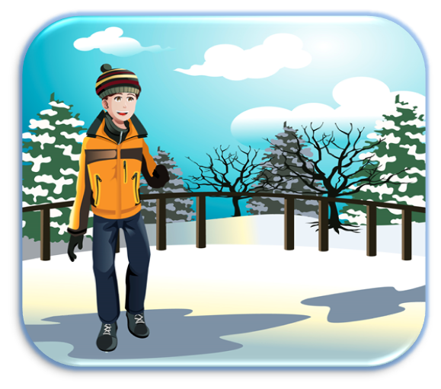

Scott usually wakes up at 6.00 am. He always drinks a liter of water after he gets up. He says it is very important to be hydrated. He meditates from 6.10 to 6.30 am. He feels meditation is an essential element to avoid stress. He watches a TED talk or reads a little from 6.30 to 7.00 am. These activities give him inspiration to start the day. He exercises from 7.00 to 8.00 am. He says exercising clarifies his ideas. Then, he takes a cold shower at 8.10 am. He thinks cold showers increase testosterone levels and improve circulation. He has breakfast at 8.40 am. He usually has vegetable juice, bananas, peanut butter, and almonds. Finally, he does all his creative work from 8.40 to 12.00 m.

1. **Read the text, underline the verbs in third singular person, translate the text line by line**
2. **Answer about the text**
3. **Who is He?**
4. **What time does he get up?**
5. **What activities does he do?**
6. **What does he eat and drink for breakfast?**
7. **Why is the meditation important for Scott?**