|  |  |  |
| --- | --- | --- |
| **COLEGIO INSTITUTO TECNICO INTERNACIONAL IED.**  **P.E.I. EDUCACIÓN EN TECNOLOGÍA Y SU INFLUENCIA EN LA CALIDAD DE VIDA** | | |
| **DOCENTE: CONSUELO MARTINEZ** | **ASIGNATURA: INGLÉS** | **GRADO: 9ª CURSO: 903** |
| **CÓDIGO: II-13-07-03-2020** | **TEMA: Past Events and Music** | |
| **GRADE:** | **NAME:** | |

**Performances**

Read and comprehend short texts about Music.

Use the simple past tense in a real context.

Students establish the difference between regular and irregular verbs

**Regular verbs**: these verbs formed its past and past participle by adding -ed or -d, for example: cry-cried, refuse-refused.

**Irregular verbs**: these verbs don't follow a fixed pattern or rule, for example: begin-began, put-put , buy- bought

**A.In the letter puzzle identify and circle the past of the following verbs: brush, drink, drive, eat, have, listen, make, play, read, shave, sleep, study, take, wake, watch**

|  |  |  |  |  |  |  |  |  |  |  |  |  |  |  |
| --- | --- | --- | --- | --- | --- | --- | --- | --- | --- | --- | --- | --- | --- | --- |
| **Y** | **W** | **O** | **A** | **T** | **E** | **L** | **M** | **E** | **Y** | **Z** | **T** | **O** | **C** | **U** |
| **O** | **R** | **L** | **H** | **X** | **U** | **L** | **G** | **K** | **D** | **E** | **Y** | **A** | **L** | **P** |
| **O** | **E** | **W** | **W** | **I** | **B** | **X** | **P** | **O** | **T** | **M** | **G** | **T** | **Y** | **S** |
| **N** | **A** | **H** | **R** | **Z** | **K** | **O** | **M** | **O** | **I** | **S** | **E** | **S** | **E** | **W** |
| **G** | **D** | **X** | **A** | **S** | **L** | **E** | **P** | **T** | **W** | **V** | **H** | **K** | **N** | **L** |
| **E** | **I** | **B** | **P** | **T** | **P** | **R** | **D** | **R** | **S** | **H** | **A** | **V** | **S** | **D** |
| **E** | **Z** | **R** | **Q** | **U** | **Y** | **D** | **Y** | **E** | **L** | **L** | **D** | **I** | **W** | **X** |
| **B** | **J** | **U** | **V** | **D** | **P** | **E** | **J** | **H** | **O** | **H** | **N** | **B** | **G** | **Y** |
| **Q** | **L** | **S** | **Z** | **I** | **Z** | **S** | **L** | **I** | **S** | **T** | **E** | **N** | **E** | **D** |
| **B** | **Z** | **H** | **H** | **E** | **H** | **X** | **Y** | **F** | **O** | **O** | **F** | **Q** | **A** | **E** |
| **F** | **S** | **E** | **P** | **D** | **R** | **A** | **N** | **K** | **Y** | **A** | **A** | **G** | **R** | **H** |
| **U** | **M** | **D** | **Y** | **N** | **D** | **Z** | **O** | **Z** | **T** | **J** | **J** | **I** | **C** | **C** |
| **T** | **Y** | **A** | **E** | **V** | **O** | **E** | **V** | **O** | **R** | **D** | **E** | **O** | **R** | **T** |
| **L** | **V** | **H** | **T** | **N** | **X** | **M** | **R** | **G** | **C** | **T** | **X** | **G** | **E** | **A** |
| **M** | **A** | **D** | **E** | **Q** | **C** | **K** | **W** | **X** | **J** | **T** | **E** | **K** | **O** | **W** |

**B. Complete the following sentences with the past of the verb.**

1. Tom………...like a baby last night
2. He …………...hard for the test last week.
3. Sam………….the bus to school this morning
4. We ………….Basketball all afternoon.
5. I………………..my bed before going to school.
6. They…………..TV while having breakfast.
7. Michael…………….up early on Monday.
8. He……………..a very interesting book last month.
9. I……………...too much beer yesterday.
10. She…………….to some music.
11. John……………..his teeth before going to bed.
12. I…………………...all the cookies in the jar.
13. He……………..before going to work.
14. My grandpa………………..me to school yesterday.
15. Mrs. Collins……………..a hot bath.

**C. Tommy´s Day**

Yesterday was a terrible day for Tommy, he woke up early and he was too hungry, so he decided to have a glass of orange juice and a piece of toast, but his dog Pluto was really impatient, he wanted     Tommy to take him for a walk. Tommy stopped eating and put on a track suit, his trainers and a heavy coat, it was really cold outside. They went out and walked around the park. Pluto run, jumped and played with other dogs . Tommy sat and looked Pluto, his hands were freezing and he couldn´t stop thinking about his warm bed. When Tommy looked at the time he decided to go back home, he had time to take a bath and go to work. Pluto did not want to go, he was really happy. When he arrived home, he realized he didn´t have his keys, so he decided to call a locksmith but he also forgot his cell phone in the apartment and his neighbors were on vacation. He stayed out for more than an hour until his girlfriend arrived to pick up him and she opened the door with her keys. He was really cold and upset, he couldn´t take a bath and he was late for work.

**Reading Comprehension**

1. Why did Tommy stop eating?
2. Because he wanted to go out
3. Because his dog wanted to go out
4. Because he was very impatient

      2. What was the weather like?

1. It was cold
2. It was warm
3. None of the above.

      3. Why did Pluto do in the park?

1. He run and jumped around the park
2. He sat next to Tommy
3. He was really impatient and went back home.

      4. Why did Tommy decide to go back home?

1. Because he couldn't stop thinking about his warm bed
2. Because he was late for work
3. Because he had time just to take a bath and go to work.

      5. Why was Tommy upset and cold?

1. Because he forgot his keys and had to wait for a locksmith
2. Because the locksmith took more an hour to arrive.
3. Because he couldn't call the locksmith.

      6. When did he call the locksmith?

1. When he arrived home.
2. When his girlfriend arrived
3. He couldn't call the locksmith.

      7. Did Tommy take a bath?

1. Yes, he did
2. No, he didn't
3. None of the above

     Write true or false

       8. Tommy forgot his keys and his cellphone at home

1. True
2. False
3. Not mentioned

    9. The locksmith opened Tommy´s door after one hour

1. True
2. False
3. Not mentioned.

     10. Pluto was happy to go back home

1. True
2. False
3. Not mentioned

**D. Ask about yourself and ask your friends or your family**

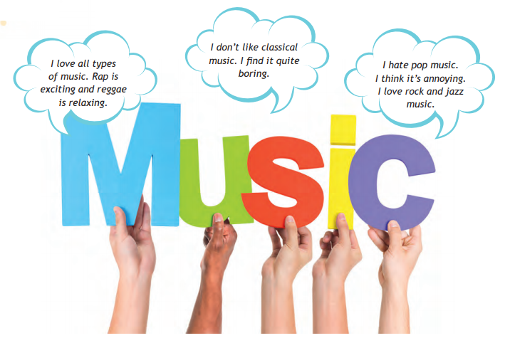

|  |  |  |  |  |
| --- | --- | --- | --- | --- |
| QUESTIONS | YOUR TEACHER | YOU | PERSON 1 | PERSON 2 |
| Do you like music? | Yes, I like it. |  |  |  |
| What type of music do you like? | I like rock, pop and romantic music. |  |  |  |
| Do you feel happy when you listen to music? | Yes, music relaxes me very much. |  |  |  |
| Do you dance when you hear music? | some times. |  |  |  |
| Do you listen to music on your phone, on the radio, on a CD player, on a memory? | I listen to music on a CD player. |  |  |  |

**E. Read the the text and answer the questions Yes ( Y) or No ( N) correct  the No answers.**

Hi there. I’m Santiago, I’m 16 and I love music - it’s my hobby. My favourite type of music is rock – I listen to it every day and there are a few bands that I follow – I’m crazy about them. There are other types of music that I like, but rock is my favourite. I don’t like vallenato – it’s boring.

Hi. My name’s Jan and I’m 15 years old. Music is very important in my life. All my family loves playing and listening to music. My dad and I play the guitar together, but we have very different music taste. I enjoy listening to metal – I find it really exciting. My father loves classical music – he says it’s relaxing.

Hi, I’m Annie, I always sing when I listen to music that I like. My favourite types of music are salsa and merengue. It’s amazing – when I listen to that type of music I feel happy! Music plays a big role in my life because my mum is a music teacher and our whole family is musical. I play the piano and my sister plays the flute.

My name’s Lola and I’m 14 years old. For me, music is an important part of my life – I like listening to it in my bedroom. I remember good times when I listen to music. I love pop music, but I can’t stand listening to metal. Metal is annoying.

1. Does Santiago only like rock music?

2. Does he think vallenato music is boring?

3. Does Jan play the same instrument as her dad?

4. Does Jan’s dad think classical music is exciting?

5. Does Annie like more than one type of music?

6. Does she play any instruments?

7. Does Lola like listening to music in her bedroom?

8. Does Lola think pop music is annoying?

Taken from English Please 1. Colombia Aprende

**E.Listen the song : paradise ( coldplay)** <https://www.youtube.com/watch?v=nSLSkRP6X3U>

1. Write the biography of coldplay

      2. Write ten sentences from the song where you can evidence the past tense

      3.  Write the message of the song

      4. Do you like the song? Why?

       Note: si tiene dudas sobre verbos regulares e irregulares revisar la lista que se les envió para la sesión virtual o ver el siguiente vídeo. <https://www.youtube.com/watch?v=8CHdzfWdHeg>

AUTO EVALUACIÓN

¿Qué aprendió?

¿Qué se le facilitó?

¿Qué se le dificultó?