|  |  |  |
| --- | --- | --- |
| **COLEGIO INSTITUTO TECNICO INTERNACIONAL IED.**  **P.E.I. EDUCACIÓN EN TECNOLOGÍA Y SU INFLUENCIA EN LA CALIDAD DE VIDA** | | |
| **DOCENTE: CONSUELO MARTINEZ** | **ASIGNATURA: INGLÉS** | **GRADO: 9ª CURSO: 903** |
| **CÓDIGO: II-09-05-17-2020** | **TEMA: Comparatives and Superlatives** | |
| **GRADE:NINTH** | **NAME:** | |

DESEMPEÑOS

Identifica la estructura de los comparativos y superlativos

Establece la diferencia entre comparativos y superlativos

1. Watch the video and write the examples that appear here

Comparative and superlative 1 syllable

_______________________________________

_______________________________________

_______________________________________

_______________________________________

two or more syllables

_______________________________________

_______________________________________

_______________________________________

_______________________________________

_______________________________________

adjectives ending Y

________________________________________

_______________________________________

________________________________________

________________________________________

Irregular adjectives

________________________________________

________________________________________

________________________________________

________________________________________

Comparing equals

__________________________________________

__________________________________________

_________________________________________

_________________________________________

The next chart is for helping to understand comparatives and superlatives

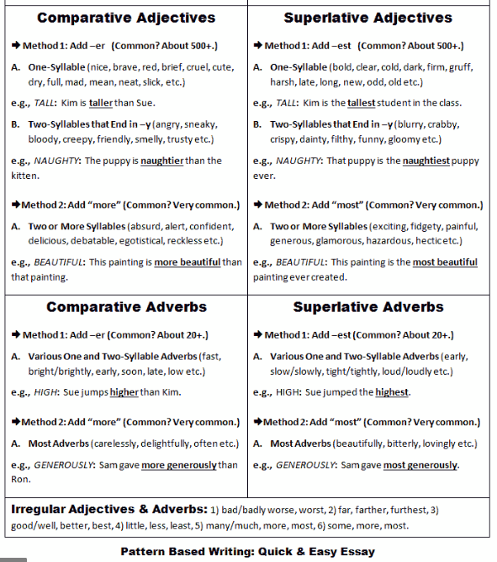

2. Complete following the example

1. He/ happy/ his wife

He is happier than his wife

1. Spain is/ hot/ France

_________________________________

1. The sandwiches are/ expensive/ the drinks

__________________________________

1. David speaks Italian/ good/ Kim

__________________________________

1. Sydney is/ far from London/ Delhi

__________________________________

1. He is/ tall/ brother

_________________________________-

1. Claire works/ hard/ Sally

_________________________________

1. The traffic at 8:30 is/ bad / the traffic at 9: 30

_________________________________

1. Harry writes/ quickly/ Paul

_________________________________

1. Life in the city is/ stressful/ life in the country  
   ___________________________________

3. Rewrite the sentences using not as….as

1. .His wife/ happy

His wife isn`t as happy as him

b. France/ hot/ Spain

___________________________

c. The drinks/ expensive/ sandwiches

_____________________________

d. Kim/ good/ David

______________________________

e. Delhi/ far/ Sidney

_______________________________

f. His brother/ tall/ He

_______________________________

g.Sally/ beautiful/ her mother

_______________________________

h. The traffic at 9: 30/ bad/ the traffic at 8:30

_________________________________

i.Paul/ write/quickly/ Harry

___________________________________

j.Life in the country/ stressful/ city

___________________________________

4. Write the opposites

1. The most friendly The friendliest
2. The most expensive __________________
3. The most exciting __________________
4. The most generous __________________
5. The most patient __________________
6. The loudest __________________
7. The most crowded __________________
8. The most hard working __________________

5. Reading Comprehension

**THE “ BIG TREE”**

The sequoia is the tallest tree in the world. Some sequoias are taller than many buildings. Some are heavier than 500 cars. One tree was so large that people built a dance floor in its base. In 1891 it took two men 13 days to cut the Mark Twain Tree. Its diameter was 16 feet( 4.87 meters). it weighed 9 tons ( 9.900 Kgs.) and it was 331 feet high( 101 meters).

Today the tallest giant Sequoia is McKinley`s Tree. It grows in Kings Canyon Park in California. It is 291 feet ( 89 meters) tall. It has enough wood to build four houses, and maybe enough to make some furniture too.

A Sequoia can take 500 years to grow to its full height. After that it lives for hundreds of years. The giant Sequoia, or “ big tree”, live longer than the others.

Its average age is between 3.000-4.000 years. It's difficult to imagine all the changes that can happen in our world during the lifetime of a Sequoia.

About the reading

Choose the correct answer.

1. Sequoias are the
2. greatest trees in the world.

b.tallest

c.greenest

2. Some Sequoias are

a. shorter than Christmas trees

b. thinner than apple trees.

c. heavier than five hundred cars.

3. McKinley`s Tree is

a. smaller than the Mark Twain Tree.

b. bigger

c. older

4. McKinley`s Tree has enough wood

1. to build a stadium.
2. to build a few houses and furniture.
3. for California.

5. A Sequoia tree

1. grows for a thousand years.
2. lives for a short time.
3. lives for a long time.