COLEGIO INTERNACIONAL
CURSO 601 – 602 – 603 – 604. JORNADA MAÑANA
JEREMIAS LADINO CORONADO
ESTA ACTIVIDAD 11 ES PARA TRABAJARLA EN DOS SEMANAS.
- ESTUDIAR Y APRENDER EL VOCABULARIO MUY BIEN
- DESARROLLAR LOS EJERCICIOS
- APRENDER LA CANCION : THE ANIAMALS ON THE FARM
Desarrollar el taller en Word, en la misma guía y enviarla para su evaluación con fecha limite el viernes 8 de MAYO 2020 al correo jelaco5454@hotmail.com. La sustentación la presentará cuando regresemos. Cada parte vale el 50%

VOCABULARY 11
- Dog | dog |  | perro | Fish |  | fich |  | Pez
Cat | cat |  | gato | insect |  | insect |  | Insecto
Monkey | monki |  | Mono, mico | jungle |  | yongol |  | Selva,jungla
Mouse | máus |  | ratón | farm |  | Farm |  | Granja
Cow | kau |  | vaca | fox |  | foks |  | zorro
Horse | jours |  | caballo | Chicken |  | chiken |  | Pollo
Lion | laien |  | león | Hen |  | jen |  | Gallina
Tiger | taier |  | tigre | Rooster/cock |  | Ruster/cok |  | Gallo
Panter | pánter |  | pantera | turkey |  | torki |  | pavo
Elphant | élefant |  | elefante | Donky |  | donki |  | Burro
Duck | dok |  | pato | Rabbit |  | rábit |  | Conejo
sea | si |  | mar
turtle | tortol |  | tortuga | dolphin |  | dolfin |  | Delfin
forest | forest |  | bosque | bear |  | béar |  | oso
hummingbird | jómingberd |  | colibri | bear |  | béar |  | Oso
parrot | párot |  | loro | tree |  | tri |  | Árbol
river | river |  | rio | Dove/pigeon |  | Dof/píyen |  | Paloma
frog | frog |  | rana | fly |  | flai |  | Mosca
wolf | úolf |  | lobo | giraffe |  | yiraf |  | Girafa
At home | At jom |  | En casa | zebra |  | zibra |  | Cebra
pig | pig |  | cerdo | lake |  | leik |  | Lago
animal | anomol |  | animal | desert |  | désert |  | Desierto
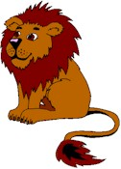 |  |  |  | WHAT ANIMAL IS THIS?  QUÉ ANIMAL ES ESTE?  IT IS A TIGER  ES UN TIGRE  WHERE IS THE TIGER ?  DÓNDE ESTÁ EL TIGRE?  IT IS IN THE JUNGLE  ESTÁ EN LA SELVA
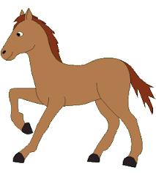 |  | WHAT ANIMAL IS THIS?  __________________  WHERE IS THE __________?  IT IS_______________ |  |  | 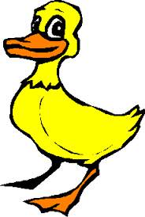 |  | WHAT ANIMAL IS THIS?  __________________  WHERE IS THE __________?  IT IS_______________
 |  | WHAT ANIMAL IS THIS?  __________________  WHERE IS THE __________?  IT IS_______________ |  |  | 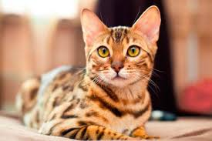 |  | WHAT ANIMAL IS THIS?  __________________  WHERE IS THE __________?  IT IS_______________
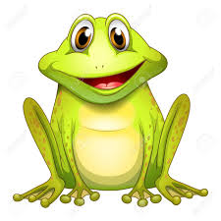 |  | WHAT ANIMAL IS THIS?  __________________  WHERE IS THE __________?  IT IS_______________ |  |  |  |  | WHAT ANIMAL IS THIS?  __________________  WHERE IS THE __________?  IT IS_______________
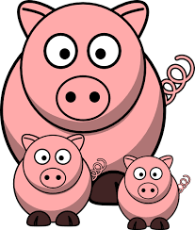 |  | WHAT ANIMAL IS THIS?  __________________  WHERE IS THE __________?  IT IS_______________ |  |  | 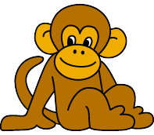 |  | WHAT ANIMAL IS THIS?  __________________  WHERE IS THE __________?  IT IS_______________
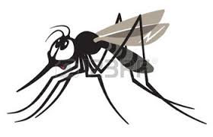 |  | WHAT ANIMAL IS THIS?  __________________  WHERE IS THE __________?  IT IS_______________ |  |  | 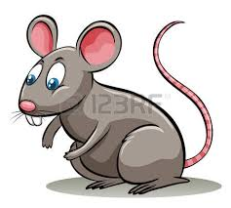 |  | WHAT ANIMAL IS THIS?  __________________  WHERE IS THE __________?  IT IS_______________
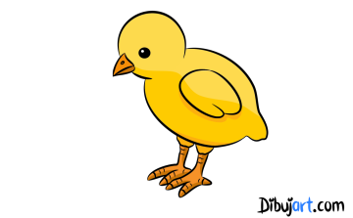 |  | WHAT ANIMAL IS THIS?  __________________  WHERE IS THE __________?  IT IS_______________ |  |  | 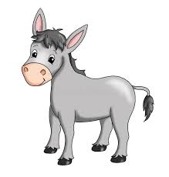 |  | WHAT ANIMAL IS THIS?  __________________  WHERE IS THE __________?  IT IS_______________
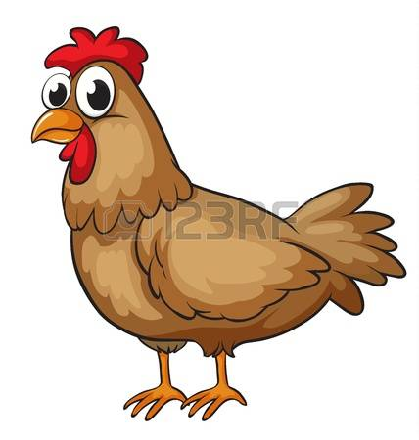 |  | WHAT ANIMAL IS THIS?  __________________  WHERE IS THE __________?  IT IS_______________ |  |  | 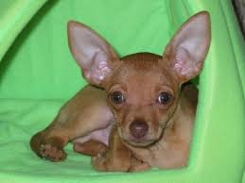 |  | WHAT ANIMAL IS THIS?  __________________  WHERE IS THE __________  IT IS_______________
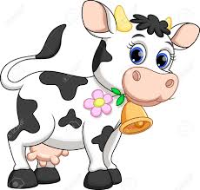 |  | WHAT ANIMAL IS THIS?  __________________  WHERE IS THE __________?  IT IS_______________ |  |  | 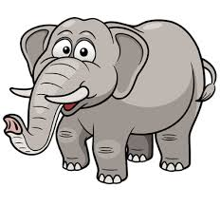 |  | WHAT ANIMAL IS THIS?  __________________  WHERE IS THE __________?  IT IS_______________
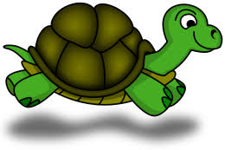 |  | WHAT ANIMAL IS THIS?  __________________  WHERE IS THE __________?  IT IS_______________ |  |  | 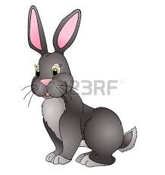 |  | WHAT ANIMAL IS THIS?  __________________  WHERE IS THE _________  IT IS_______________
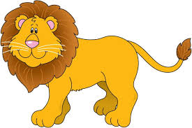 |  | WHAT ANIMAL IS THIS?  __________________  WHERE IS THE __________?  IT IS_______________ |  |  |  |  | WHAT ANIMAL IS THIS?  __________________  WHERE IS THE __________?  IT IS_______________
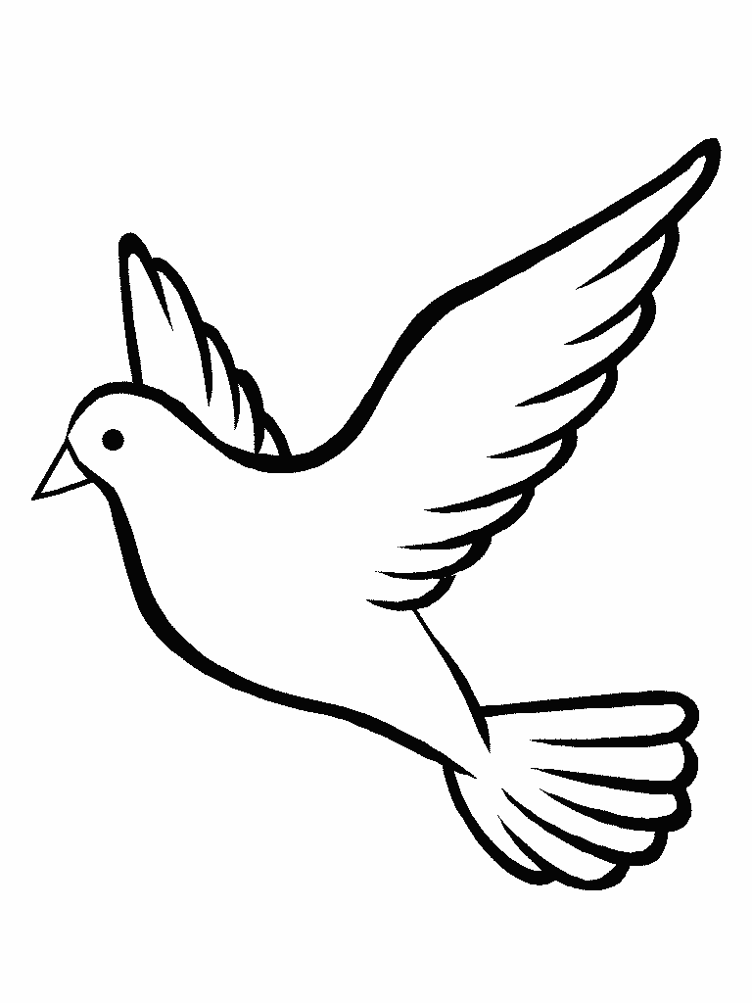 |  | WHAT ANIMAL IS THIS?  __________________  WHERE IS THE __________?  IT IS_______________ |  |  | 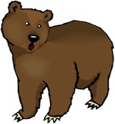 |  | WHAT ANIMAL IS THIS?  __________________  WHERE IS THE __________?  IT IS_______________
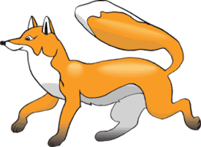 |  | WHAT ANIMAL IS THIS?  __________________  WHERE IS THE __________?  IT IS_______________ |  |  | 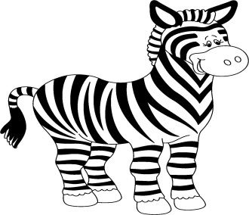 |  | WHAT ANIMAL IS THIS?  __________________  WHERE IS THE __________?  IT IS_______________
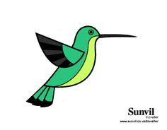 |  | WHAT ANIMAL IS THIS?  __________________  WHERE IS THE __________?  IT IS_______________ |  |  | 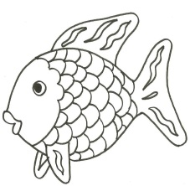 |  | WHAT ANIMAL IS THIS?  __________________  WHERE IS THE __________?  IT IS_______________
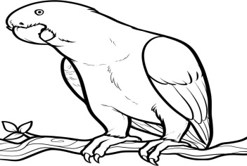 |  | WHAT ANIMAL IS THIS?  __________________  WHERE IS THE __________?  IT IS_______________ |  |  | 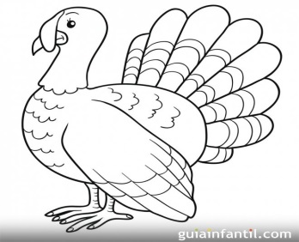 |  | WHAT ANIMAL IS THIS?  __________________  WHERE IS THE __________?  IT IS_______________
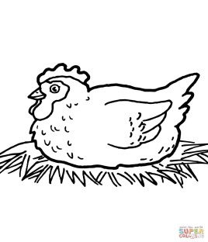 |  | WHAT ANIMAL IS THIS?  __________________  WHERE IS THE __________?  IT IS_______________ |  |  | 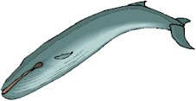 |  | WHAT ANIMAL IS THIS?  __________________  WHERE IS THE __________?  IT IS_______________
ENTRAR, PRACTICAR Y APRENDER ESTA CANCIÓN https://www.crecereningles.com/animales-canciones-ingles/
THE ANIMALS ON THE FARM
The ducks on the farm say, «Quack, quack, quack.»
The mice on the farm say, «Squeak, squeak, squeak.»
The chickens on the farm say, «Cluck, cluck, cluck.»
«Quack. Squeak. Cluck.»
The pigs on the farm say, «Oink, oink, oink.»
The goats on the farm say «Meh, meh, meh.»
The sheep on the farm say «Baa, baa, baa.»
«Oink. Meh. Baa.»
The horses on the farm say, «Neigh, neigh, neigh.»
The cows on the farm say, «Moo, moo, moo.»
The roosters on the farm say, «Cock-a-doodle-doo.»
«Neigh. Moo. Cock-a-doodle-doo.»
«Neigh. Moo. Cock-a-doodle-doo.»
Let’s try it a little faster.
The ducks on the farm say, «Quack, quack, quack.»
The mice on the farm say, «Squeak, squeak, squeak.»
The chickens on the farm say, «Cluck, cluck, cluck.»
«Quack. Squeak. Cluck.»
Okay, a little faster.
The pigs on the farm say, «Oink, oink, oink.»
The goats on the farm say «Meh, meh, meh.»
The sheep on the farm say «Baa, baa, baa.»
«Oink. Meh. Baa.»
Okay, super fast!
The horses on the farm say, «Neigh, neigh, neigh.»
The cows on the farm say, «Moo, moo, moo.»
The roosters on the farm say, «Cock-a-doodle-doo»
«Neigh. Moo. Cock-a-doodle-doo.»
«Neigh. Moo. Cock-a-doodle-doo.»

.
G | M | S | Z | B | P | F | H | O | R | S | E
S | P | I | D | E | R | H | E | N | A | L | G
A | E | D | L | R | A | B | B | I | T | X | O
K | Y | P | E | L | E | P | H | A | N | T | R
I | P | B | I | D | O | L | P | H | I | N | I
C | A | T | A | G | A | A | C | W | Y | V | L
Q | A | M | H | X | H | N | O | H | X | M | L
T | X | G | O | Z | D | T | C | F | M | A | A
S | Q | W | H | A | L | E | K | V | Y | D | Q
G | E | H | A | M | S | T | E | R | E | N | U
U | Z | A | O | D | S | A | Q | E | M | Y | R
W | O | L | L | H | F | G | R | A | K | V | A
- SPIDER
- WHALE
- HORSE
- PIG
- DEER
- ELEPHANT
- RABBIT
- DOLPHIN
- SEAL
- HEN
- COCK
- CAT
- GORILLA
- HAMSTER
- ANT

UN ABRAZO. DISFRUTE SU TRABAJO.

