ACTIVITY FOUR

|  |  |  |  |  |  |  |
| --- | --- | --- | --- | --- | --- | --- |
| What is this? | | | | It´s a staplerResultado de imagen para dibujos de objetos de la clase en ingles | | |
| PENCIL  STAPLER  BOARD  RUBBER  SCHOOL BAG  CHAIR  WHAT  BOOK  GLUE  SCISSORS  CALCULATOR  CRAYON  GLOBE  BOOKCASE  DUSTER  CHOLKS  DUSTBIN  WINDOW  CLOCK | PÉNCIL  STÉIPLER  BOURD  ROBER  SKUL BAG  CHEAR  JUAT  BUK  GLU  SISORS  CÁLKIULEIRER  KREION  GLOB  BUKEIS  DOSTER  CHOKS  DOSTBIN  UINDOU  CLOK | LÁPIZ  ENGRAPADORA  TABLERO  BORRADOR  MORRAL  SILLA  QUE  LIBRO  PEGANTE  TIJERAS  CALCULADORA  LÁPIZ DE COLOR  MAPAMUNDI  LIBRERÍA  PLUMERO  TIZAS  BASURA  VENTANA  RELOJ | PENCIL CASE  COMPUTER  ERASER  BAG  NOTEBOOK  RULER  DESK  PENCIL SHARPENER  THIS  CALENDAR  PEN  PAPERS  PICTURE  TEACHER´S DESK  DOOR  MAP | | PÉNCIL KEIS  KEMPÍURER  IRÉISER  BAG  NOUTBUK  RULER  DESK  PENCIL CHARPENER  DIS  CÁLENDER  PEN  PEIPERS  PICHER  TICHER DESK  DOR  MAP | CART  COMPUTADOR  BORRADOR  MALETA  CUADERNO  REGLA  ESCRITORIO  LAPIZ  SACAPUNTAS  ESTO  CALENDARIO  ESFERO  PAPELES  CUADRO  ESCRITORIO DEL PROFE  PUERTA  MAPA |

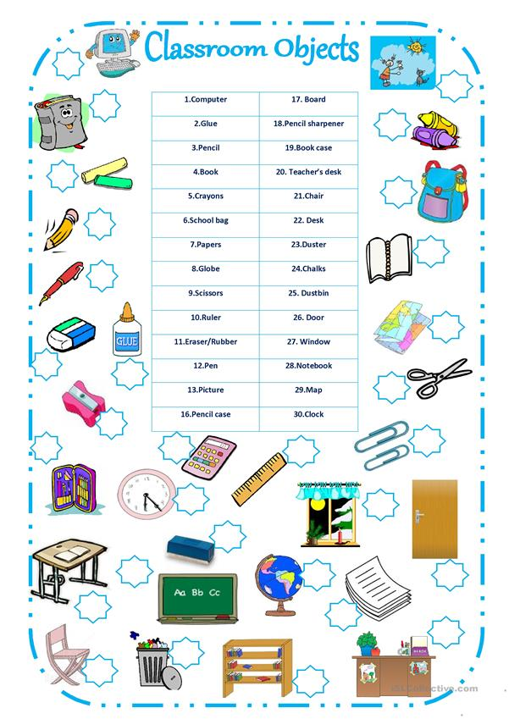

ACTIVITY 5: SPEAKING

|  |  |  |
| --- | --- | --- |
| [http://ts3.mm.bing.net/th?id=I.4698140886237662&pid=1.9](http://www.bing.com/images/search?q=dibujos+para+colorear+profesiones++constructores+primeraescuela&view=detail&id=726A4CE09357F14A26FD4405CA8E3BE2A2C857C4&FORM=IDFRIR)  I AM JHON | [http://ts3.mm.bing.net/th?id=I.4698140886237662&pid=1.9](http://www.bing.com/images/search?q=dibujos+para+colorear+profesiones++constructores+primeraescuela&view=detail&id=726A4CE09357F14A26FD4405CA8E3BE2A2C857C4&FORM=IDFRIR)  WHAT IS YOUR NAME | [http://ts4.mm.bing.net/th?id=I.4592879845311279&pid=1.1](http://www.bing.com/images/search?q=dibujos+para+colorear++objetos++primeraescuela&view=detail&id=232F1A286C09C02F7725FB04C35BCF073207E7A3&FORM=IDFRIR)  MY NAME IS JESUS |
| [http://ts3.mm.bing.net/th?id=I.4698140886237662&pid=1.9](http://www.bing.com/images/search?q=dibujos+para+colorear+profesiones++constructores+primeraescuela&view=detail&id=726A4CE09357F14A26FD4405CA8E3BE2A2C857C4&FORM=IDFRIR)  NICE TO MEET YOU JESUS | [http://ts4.mm.bing.net/th?id=H.4893222711853859&pid=1.9](http://www.bing.com/images/search?q=DIBUJO+STRECHAR+MANOS&view=detail&id=37F1FF1314AC160B098207051A732EE30EBCFFA4)  NICE TO MEET YOU, TOO | [http://ts3.mm.bing.net/th?id=I.4698140886237662&pid=1.9](http://www.bing.com/images/search?q=dibujos+para+colorear+profesiones++constructores+primeraescuela&view=detail&id=726A4CE09357F14A26FD4405CA8E3BE2A2C857C4&FORM=IDFRIR)  JESUS, THIS IS CAROL |
| [http://ts3.mm.bing.net/th?id=H.4533708222367790&pid=1.9](http://www.bing.com/images/search?q=DIBUJO+E+NI%c3%91AS&view=detail&id=69A696A7D0EFD10817D7EBFADDEB89CFE65B0119&qpvt=DIBUJO+E+NI%c3%91AS&FORM=IDFRIR)CAROL IS A STUDENT | [http://ts4.mm.bing.net/th?id=H.4609772077515175&pid=1.9](http://www.bing.com/images/search?q=MAPA+DE+LA+CIUDAD+DE+BOGOTA&view=detail&id=09B221DF9C65FBECD20AD7DA218B915AB98C01A0&first=331&FORM=IDFRIR)  SHE IS FROM BOGOTA | [http://ts3.mm.bing.net/th?id=H.4533708222367790&pid=1.9](http://www.bing.com/images/search?q=DIBUJO+E+NI%c3%91AS&view=detail&id=69A696A7D0EFD10817D7EBFADDEB89CFE65B0119&qpvt=DIBUJO+E+NI%c3%91AS&FORM=IDFRIR)[http://ts3.mm.bing.net/th?id=I.4698140886237662&pid=1.9](http://www.bing.com/images/search?q=dibujos+para+colorear+profesiones++constructores+primeraescuela&view=detail&id=726A4CE09357F14A26FD4405CA8E3BE2A2C857C4&FORM=IDFRIR)  SHE IS VERY PREETY |
| [http://ts3.mm.bing.net/th?id=I.4698140886237662&pid=1.9](http://www.bing.com/images/search?q=dibujos+para+colorear+profesiones++constructores+primeraescuela&view=detail&id=726A4CE09357F14A26FD4405CA8E3BE2A2C857C4&FORM=IDFRIR)[http://ts2.mm.bing.net/th?id=H.4749839551563881&pid=1.9](http://www.bing.com/images/search?q=DIBUJOS+DE+NI%c3%91OS&view=detail&id=8AC0217CDAA122D3E67BD3395967A4E8B98E2B03&first=91&FORM=IDFRIR)  WHO IS THAT HANDSOME BOY? | [http://ts2.mm.bing.net/th?id=H.4749839551563881&pid=1.9](http://www.bing.com/images/search?q=DIBUJOS+DE+NI%c3%91OS&view=detail&id=8AC0217CDAA122D3E67BD3395967A4E8B98E2B03&first=91&FORM=IDFRIR)  HE IS MY BROTHER | [http://ts2.mm.bing.net/th?id=H.4749839551563881&pid=1.9](http://www.bing.com/images/search?q=DIBUJOS+DE+NI%c3%91OS&view=detail&id=8AC0217CDAA122D3E67BD3395967A4E8B98E2B03&first=91&FORM=IDFRIR) |

|  |  |  |  |  |  |  |  |  |  |  |  |  |  |  |  |  |  |  |  |  |  |  |  |  |  |  |  |  |  |  |  |  |  |  |  |  |  |  |  |  |  |  |  |
| --- | --- | --- | --- | --- | --- | --- | --- | --- | --- | --- | --- | --- | --- | --- | --- | --- | --- | --- | --- | --- | --- | --- | --- | --- | --- | --- | --- | --- | --- | --- | --- | --- | --- | --- | --- | --- | --- | --- | --- | --- | --- | --- | --- |
| |  |  |  | | --- | --- | --- | | WHAT | JUAT | CUAL,QUE | | YOUR | IUR | SU | | NICE | NAIS | AGRADABLE | | MY | MAI | MI, MIS | | THIS | DIS | ESTO, ESTA | | PRETTY | PRERY | BONITA | | THAT | DAT | ESE, ESA | | |  |  |  | | --- | --- | --- | | NAME | NEIM | NOMBRE | | TO MEET | TU MIT | CONOCERTE | | HIS | JIS | SU DE EL | | WHO | JU | QUIEN | | TOO | TU | TAMBIEN | | FROM | FROM | DE | | HANDSOME | JANDSOM | SIMPATICO | |

MAKE SHORT CONVERSATION-

ACTIVITY 6:

|  |  |  |  |  |  |  |  |  |  |  |  |  |  |  |  |  |  |  |  |  |  |  |  |  |  |  |  |  |  |  |  |  |  |  |  |  |  |  |  |  |  |  |  |  |  |  |  |  |  |  |  |  |  |  |  |  |  |  |  |  |  |
| --- | --- | --- | --- | --- | --- | --- | --- | --- | --- | --- | --- | --- | --- | --- | --- | --- | --- | --- | --- | --- | --- | --- | --- | --- | --- | --- | --- | --- | --- | --- | --- | --- | --- | --- | --- | --- | --- | --- | --- | --- | --- | --- | --- | --- | --- | --- | --- | --- | --- | --- | --- | --- | --- | --- | --- | --- | --- | --- | --- | --- | --- |
| |  |  |  | | --- | --- | --- | | DANCER | DANCER | BAILARINA | | WAITER | WEITER | MESERO | | MECHANIC | MEKANIK | MECANICO | | FIREMAN | FAIRMAN | BOMBERO | | TOURIST | TURIST | TURISTA | | SECRETARY | SECRETARI | SECRETARIA | | PAINTER | PAINTER | PINTOR | | COOK | KUK | COCINERO | | ELECTRICIAN | ELECTRICHEN | ELECTRICISTA | | |  |  |  | | --- | --- | --- | | TEACHER | TICHER | PROFESOR | | SINGER | SINYER | CANTANTE | | BUILDER | BILDER | COSNTRUCTOR | | FISHERMAN | FICHERMAN | PESCADOR | | BUSINESSMAN | BISNESMAN | COMERCIANTE | | BAKER | BEIKER | PANADERO | | DOCTOR | DOCTOR | DOCTOR | | LAWYER | LOIER | ABOGADO | | MAID | MEID | CRIADA | | ARTIST | ARTIST | ARTISTA | | DRIVER | DRAIVER | CONDUCTOR | |

|  |  |  |  |  |  |  |  |  |
| --- | --- | --- | --- | --- | --- | --- | --- | --- |
| **Juanita, this is Rosario.**  **she is a dancer**  Resultado de imagen para imagen de bailarina | | **Juanita, this is Carlos.**  **He is a student.**  Resultado de imagen para imagen de estudiante | | Resultado de imagen para imagene de profesor | | Resultado de imagen para imagene de constructor | | Resultado de imagen para imagene de bombero |
| Resultado de imagen para imagen de mecanico | | **[http://ts1.mm.bing.net/th?id=I.4929854360060472&pid=1.9](http://www.bing.com/images/search?q=dibujos+para+colorear+profesiones+primeraescuela&view=detail&id=BFBBA3007489771FEE075AF9D16F3CD67C71775D&FORM=IDFRIR)** | | Resultado de imagen para imagen de  niÃ±o pescador |
| Resultado de imagen para imagen de empleada del servicio para colorear | Resultado de imagen para imagen de panadero | | Resultado de imagen para imagen de pintor de pared | | Resultado de imagen para imagen de electricista | | Resultado de imagen para imagen de  niÃ±o  mesero | |
| Resultado de imagen para imagen de   doctor | Resultado de imagen para imagen de hombre de negocios | | **[http://ts3.mm.bing.net/th?id=i.4602367431150258&pid=1.9](http://www.bing.com/images/search?q=dibujos+para+colorear+profesiones++gerentes+primeraescuela&view=detail&id=9B3C5F0516767B35C7B5BDCA84F9695950086D54&FORM=IDFRIR)** | | Resultado de imagen para imagen de odontologo | | Resultado de imagen para imagen de secretaria | |
| Resultado de imagen para imagen de enfermera | **[Afficher cette image de Football](http://www.123coloring.com/coloringpages/everyday/football/images/football_015.gif)** | | Resultado de imagen para imagen de cook | | Resultado de imagen para imagen de  CAR DRIVER | | Imagen relacionada | |

|  |  |  |  |  |  |  |  |
| --- | --- | --- | --- | --- | --- | --- | --- |
| **Brother**  [*bróder]*  Hermano | **Grandmother**  [*grándmóder]*  Abuela | **Father**  [*fáder]*  Papá | **Mother**  [*móder]*  Mamá | **Uncle**  [*ánkol]*  Tío  **Daughter**  [*dórer]*  Hija  **Niece**  [*níi]*  Sobrina | | Resultado de imagen para imagenes my family | |
| **Aunt**  [*aúnt]*  Tía | **Brother**  [*bróder]*  Hermano | **Sister**  [*síster]*  Hermana | **Son**  [*són]*  Hijo |
| **Grandson**  [*gránsón]*  Nieto | **Grandaughter**  [*grándorer]*  Nieta | **Cousin**  [*cóusin]*  Primo,prima | **Nephew**  [*néfiu]*  Sobrino |
| **Who**  **ju** | **Sister in law**  **Sister in lo**  **cuñada** | **Brother in law**  **Broder in lo**  **cuñado** |  |
| **Activity 7. My family** | | | | | |  | |
| **Who is your grandmother?**  Resultado de imagen para imagenes de abuela para colorear  This is my grandmother her name is Silvia. | | | | | **Who is your father?**  Resultado de imagen para imagenes de abuelo para colorear  This is my father his name is Eduard | |

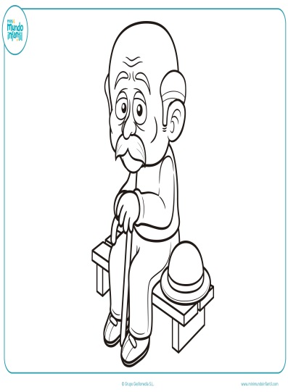 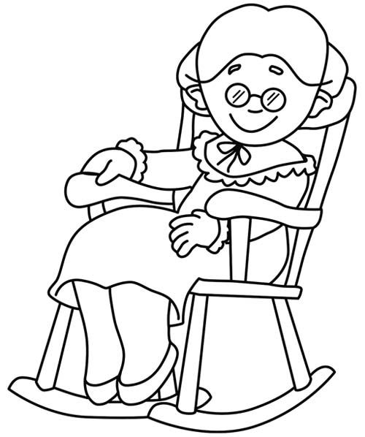  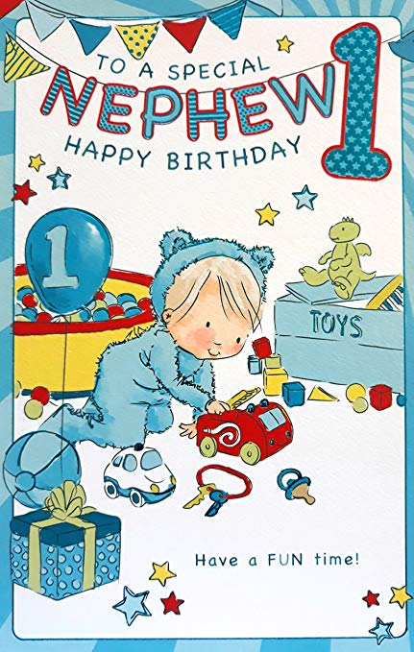 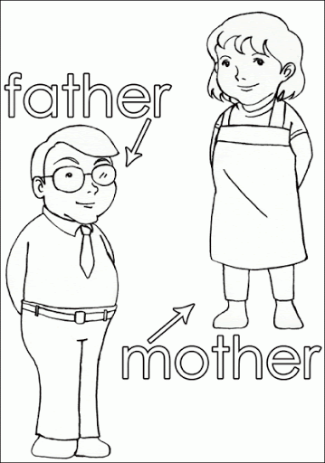 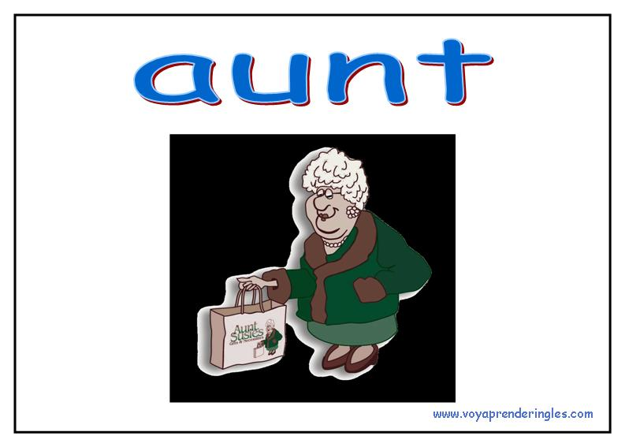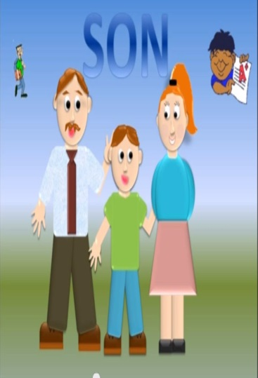 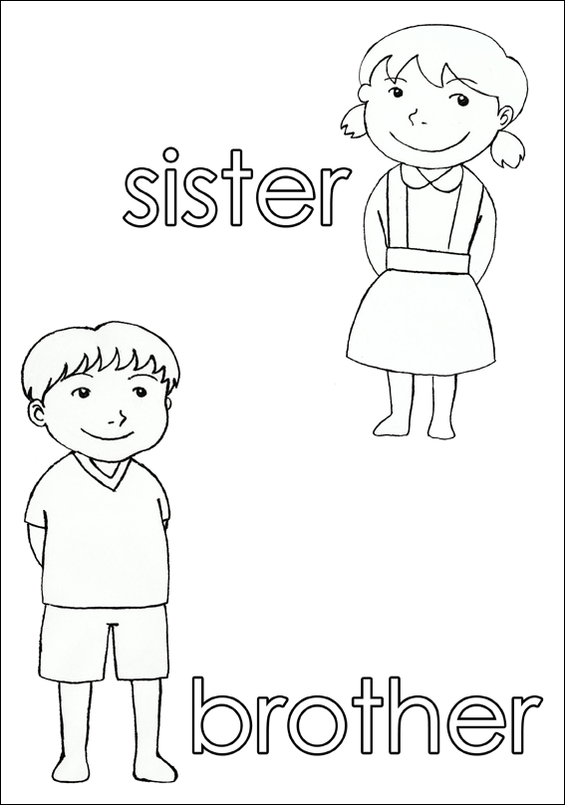  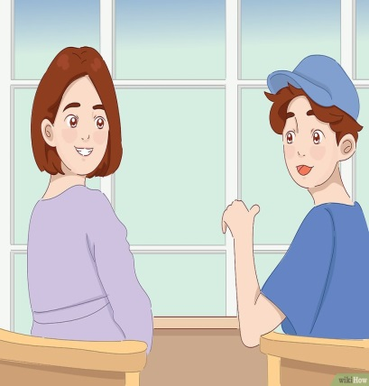

Activity 8: **WHO AM I? and my family**

|  |  |  |  |  |  |
| --- | --- | --- | --- | --- | --- |
| **YOUNG**  **[*iuang]***  **Joven** | **BRAVE**  **[*bréiv]***  **Valiente** | **CLEAN**  **[*kliim]***  **Limpio** | **STUDIOUS**  **[*studios***  **Estudioso** | **OLD**  **[*ould]***  **Viejo** | **QUIET**  **[*cuaiet]***  **Callado** |
| **TALKATIVE**  **[*tókatif***  **Hablador** | **HARDWORKING**  **[*jarduorking]***  **Trabajador** | **FRIENDLY**  **[*fréndli]***  **Amigable** | **HAPPY**  **[*jápi***  **Alegre** | **DIRTY**  ***Dirti***  **Sucio** | **SAD**  **[*sad]***  **Triste** |
| **TALL**  **[*tól]***  **Alto** | **SHORT**  **[*short***  **Bajo** | **FAT**  ***Fát***  **Gordo** | **SLIM**  ***Slim***  **Delgado** | **STRONG**  ***Stron***  **Fuerte** | **Angry**  **Ángri**  **malgeniado** |
| **In good nature**  **In gud neicher**  **De buen genio** | **Handsome**  **Jansom**  **simpático** | **Ugly**  **Ogli**  **feo** | **Smart**  **Smart**  **inteligente** | **Pretty**  **Preri**  **hermosa** | **Say**  **Sei**  **decir** |
| **Tender. Tender**  **tierna** | **Her**  **Jer. Su de ella** | **Now.nau.**  **ahora** |  |  |  |

|  |  |
| --- | --- |
|  | **Hello, my name is Paula. I am 15 years old.**  **I am short and slim. I am happy and friendly, and studious, too**  **My friends say I am in good nature and talkative** |
| Resultado de imagen para imagenes de abuelo para colorear | **This is my grandfather.**  **His name is peter, He is eighty years old. He is old, fat, and short, he is angry.**  **My grandmother says he is very smart** |
|  | **THIS IS My mother. Her name is Juanita. She is tender, slim and hardworking**  **She is 35 years old, She is very young.**  **I say she is very pretty.** |

|  |  |
| --- | --- |
| **Now, Describe your family members** | 20 DESENHOS DO DIA DA VOVÓ OU DIA DOS AVÓS PARA COLORIR, PINTAR, IMPRIMIR! |